

**YEAR: 10**

**SUBJECT: Science**

**Diet, Drugs and Nutrition**

**GENERAL Pathway**

**Please do not mark this paper**

**Year 10 Diet, Drugs and Nutrition Test**

**Part A: Multiple Choice (10 marks)**

**Record answers in the answer booklet provided.**

1. **Which of the following is NOT a sign of vitamin deficiency in the body?**
2. Brittle nails
3. Scaly skin
4. Sore bones
5. Hair loss
6. **Why do people use more energy in colder climates?**
7. Because there is less sun
8. Muscles shiver to generate warmth
9. Aching bones creates pain sensations
10. Colder climates increase the duration of urination
11. **The effect of psychomotor stimulants on the human body is to:**

a) Boost the release of certain chemicals in the brain

b) Mimic or stimulate the adrenergic nervous system

c) Stimulate the brain, speeding up mental and physical processing

d) Affect mood, behaviour and pain levels

1. **Paint and glue can be considered as drugs when abused and used inappropriately. What classification do these substances come under?**
2. Socially-acceptable drugs
3. Prescription drugs
4. Over-the-counter drugs
5. Illegal drugs
6. **Which of the following is the main fuel source for the human body?**
7. Protein
8. Fat
9. Carbohydrates
10. Minerals
11. 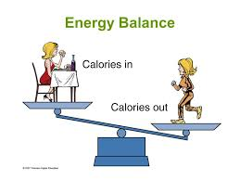**The image on the right compares calorie intake to calorie expenditure. Based on the scale, what would happen to the lady?**
12. She would gain weight
13. She would lose weight
14. Her weight would remain the same
15. She would become dehydrated
16. **Energy input is determined by:**
    1. Quantity of food consumed
    2. Type of food eaten
    3. Both a) and b)
    4. None of the above
17. **What substance is injected into an athletes’ body when they undergo “blood doping?”**
    1. Heroin
    2. Steroids
    3. Human growth hormone
    4. Blood
18. **“MDMA” and “Meth” are both forms of which classification of drug?**
    1. Muscle relaxants
    2. Hallucinogens
    3. Amphetamines
    4. Depressants
19. 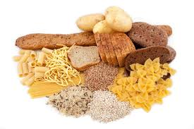**The foods in the picture on the right are all sources of:**
20. Fat
21. Carbohydrates
22. Protein
23. Vitamins



**Diet, Drugs and Nutrition Test**

**GENERAL Pathway**

**ANSWER BOOKLET**

**NAME:**

**FORM: DATE:**

**ASSESSMENT KEY**

|  |  |
| --- | --- |
| **I CAN STATEMENTS** | **QUESTIONS** |
| **MUST**  Uses the position of elements in the periodic table to make some correct predictions about their observable properties. | 1, 4, 5, 7, 8, 9, 10, 11, 12, 14, 15, 16, 18 |
| **SHOULD**  Uses the position of elements in the periodic table to determine their atomic structure and electron configuration, and makes predictions about chemical properties and reactivity. | 2, 3, 6, 12, 13, 17, 18 |
| **The General pathway is structured to assist students to achieve a C grade in Year 10 and is intended to promote engagement and future aspirations for employment.**  **The Australian curriculum is covered, but the maximum grade attainable is a B grade in this pathway.** | |

**Multiple Choice Short Answer Extended Answer Total**

**/57**

**/12**

**/35**

**/10**

**SECTION ONE: Multiple choice answers**

**Cross (X) through the correct answer.**

|  |  |  |  |  |
| --- | --- | --- | --- | --- |
| **1** | **a** | **b** | **c** | **d** |
| **2** | **a** | **b** | **c** | **d** |
| **3** | **a** | **b** | **c** | **d** |
| **4** | **a** | **b** | **c** | **d** |
| **5** | **a** | **b** | **c** | **d** |
| **6** | **a** | **b** | **c** | **d** |
| **7** | **a** | **b** | **c** | **d** |
| **8** | **a** | **b** | **c** | **d** |
| **9** | **a** | **b** | **c** | **d** |
| **10** | **a** | **b** | **c** | **d** |

**Part B: Short Answer (35 marks)**

1. Select the correct term from the list below and write it in the box next to its description. (4 marks)

fat steroids calorie MDMA

bones human growth hormone kilojoule heroin

|  |  |
| --- | --- |
| **Term** | **Description** |
|  | Provide protection for internal organs and can act as a form of insulation |
|  | Measure of energy used for food sources in Australia |
|  | Used by athletes to improve muscle mass and performance. It is only available by prescription and administered by injection |
|  | A depressant drug that slows down the body and brain |

1. 12. The food we eat has various nutritional components. In class, six main areas of nutrition were discussed. Identify each of these areas of nutrition and state how each of them assists the body in its daily functioning. (6 marks)
3. 1. ______________________________________________________________________________________________________________________________________________________
5. 2. ______________________________________________________________________________________________________________________________________________________
7. 3. ______________________________________________________________________________________________________________________________________________________
9. 4. ______________________________________________________________________________________________________________________________________________________
11. 5. ______________________________________________________________________________________________________________________________________________________
13. 6. ______________________________________________________________________________________________________________________________________________________
14. A student at Safety Bay Senior High School did a fitness test. The results can back that the student was “healthy,” but the student was not convinced that this test was accurate. The student then measured how many calories they consumed in a day, against calories expended during exercise that day. The student recorded the data in the following tables:

|  |  |
| --- | --- |
| Time of Day | Calorie Intake |
| Morning | 350 |
| Afternoon | 800 |
| Evening | 600 |

|  |  |
| --- | --- |
| Time of Day | Calorie Expenditure |
| Morning | 200 |
| Afternoon | 1200 |
| Evening | 500 |

1. Convert the above table values from calories to kilojoules (show working): (6 marks)

|  |  |
| --- | --- |
| Time of Day | Kilojoule Intake |
| Morning |  |
| Afternoon |  |
| Evening |  |

|  |  |
| --- | --- |
| Time of Day | Kilojoule Expenditure |
| Morning |  |
| Afternoon |  |
| Evening |  |

1. Compare the data from above. Is the student “healthy” or not? Justify your answer. (2 marks)

________________________________________________________________________________________________________________________________________________________________________

____________________________________________________________________________________

1. Athletes strive to attain the best results possible. In doing so, they can either take performance enhancing drugs or adopt a performance enhancing method. List an example of each below, including a desired effect and a side effect for each. (6 marks)

**Classification of performance enhancing drug:**

____________________________________________________________________________________

Desired effect:

____________________________________________________________________________________

Side effect:

____________________________________________________________________________________

**Performance enhancing method:**

____________________________________________________________________________________

Desired effect:

____________________________________________________________________________________

Side effect:

____________________________________________________________________________________

1. Use the words located in the word bank to fill in the blanks: (6 marks)

Word bank: prescription drug abused

acceptable mental mind altering

A __________ is any substance, including those required in the maintenance of health, which are taken into the body. Drugs can alter the bodies physical, ____________ or emotional structure and functioning. Prescription drugs are available only with a doctors __________________ and generally used for medicinal purposes to treat illness (i.e. antibiotics). Over-the-counter drugs are available over the counter at a chemist or a supermarket and can range from analgesics, such as paracetamol, to substances that are _______________, such as glue or paint stripper. Socially-_____________ drugsare freely available to persons over the age of 18 years which include alcohol and tobacco.

Illegal drugs are not legally available. There are severe penalties for buying or selling drugs (i.e. ecstasy, heroin and amphetamines). They are often taken so the user experiences a desired effect – usually __________________________.

1. The pictures below are of various foods. Under each picture, write the **main** nutritional value that is found in each food. (3 marks)

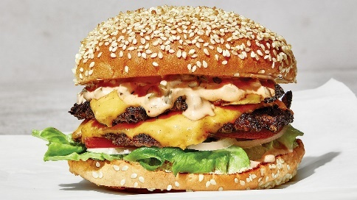 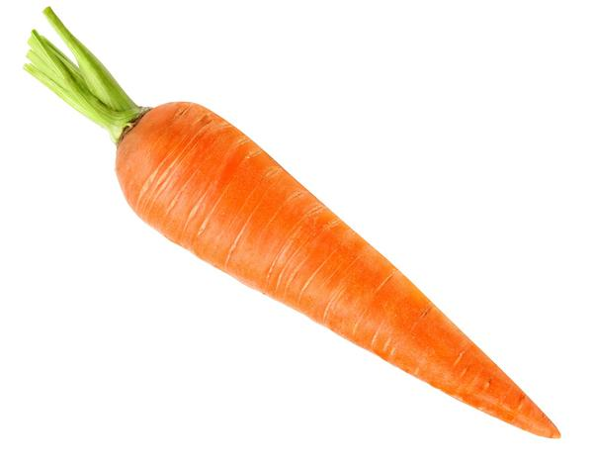 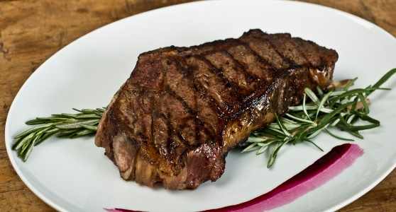

_________________________ _______________________ _____________________________

1. In modern day society, it is common for individuals to have a greater energy input in comparison to their energy output. This can lead to many health complications if lifestyle changes do not occur. Provide **two** suggestions that someone can adopt in order to balance their energy input and output. (2 marks)

________________________________________________________________________________________________________________________________________________________________________________________________________________________________________________________________________________________________________________________________________________

**END OF SHORT ANSWER SECTION**

**Part C: Extended answer** **(12 marks)**

1. Illicit drugs are a problem that have continued to impact society for decades. The best prevention against drug use is proper education on what drugs are, why people take them and the side-effects they can cause. In the space below, please discuss **four** illicit drugs covered in class. Be sure to:

* Include the name of each drug
* One desired effect of each drug
* One side effect of each drug

________________________________________________________________________________________________________________________________________________________________________________________________________________________________________________________________________________________________________________________________________________________________________________________________________________________________________________________________________________________________________________________________________________________________________________

________________________________________________________________________________________________________________________________________________________________________________________________________________________________________________________________________________________________________________________________________________________________________________________________________________________________________________________________________________________________________________________________________________________________________________________________________________________________________________________________________________________________________________________________________________

**END OF TEST.**

**PLEASE GO BACK AND ENSURE YOU HAVE EDITTED YOUR WORK AND ATTEMPTED ALL QUESTIONS**